Why String immutable and final in Java

Attached screenshot showing reasons on how string stored and used, attached 1st screenshot.

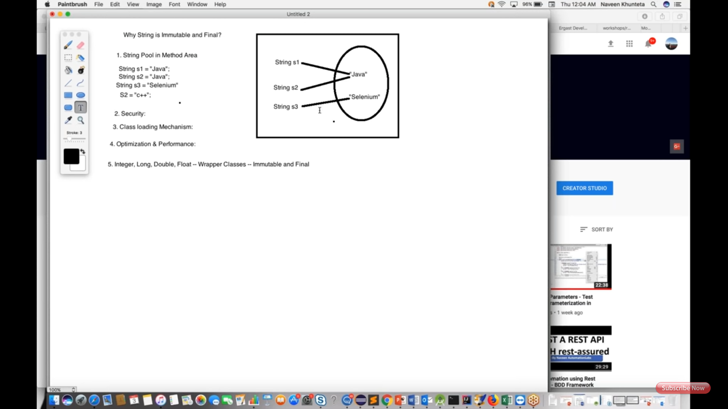

Program it shows how I'd and value same or varied for the same or different Strings in debug mode. Attached 2nd screenshot.

